CrashAlert: Enhancing Peripheral Alertness for Eyes-Busy Interaction while Walking

Anonymous 1 | Anonymous 2

ABSTRACT
Divided attention resulting from multi-tasking while walk-ing (e.g. texting, browsing the web, etc) can lead to danger-ous and sometimes life-threatening outcomes such as colliding into obstacles or other people. To avoid such risks we introduce a novel system that extends peripheral awareness through sensors embedded on mobile devices and that provides visual cues of the environment in a minimal footprint display on the device. We present CrashAlert, a system to enhance peripheral alertness and reduce the risk of collisions when walking and multi-tasking with mobile devices. We augment a mobile device with a depth sensing camera that alerts the user to the existence of obstacles outside the user’ periphery. We present the design and evaluation of CrashAlert… In an evaluation outside a lab environment, CrashAlert…
Other names: PhoneBumper / BumpAlert / CrashAlert / BumpAware / CrashAware
ACM Classification: H5.2 [Information interfaces and presentation]: User Interfaces. - Graphical user interfaces.
General terms: obstacle avoidance, multi-tasking, eyes-on interaction,
Keywords: Eyes-busy interaction, texting and walking, walking user interface.

INTRODUCTION
Mobile device users habitually multi-task (such as entering text or conversing) while walking [refs.]. Unfortunately, tasks that require a high degree of visual attention or eyes-busy interaction (such as texting) limit much of the user’s peripheral vision. Such practice has resulted in user’s tripping onto curbs, walking into traffic or deviating from their intended path [refs.]. Eyes-busy interaction while walking has led to a threefold increase in emergency room cases [ref.], forcing some states to introduce new safety policies that ban mobile device usage while walking [ref.]. However, aside from policy making, new technology for safer walking and multi-tasking is relatively unexplored.
In this paper, we introduce CrashAlert, a system that captures and displays information beyond the user’s peripheral view, using a depth camera attached to a mobile device. CrashAlert has two components: it scans the environment for obstacles that are on the user’s path, and then alerts users about the position of these objects in a minimal footprint display on the mobile screen. Numerous visual representations of the depth image are possible and our impWe implemented various visual transformations on the scanned image to keep the CrashAlert’s display at its best minimum size. [list some sample image transformations here.].
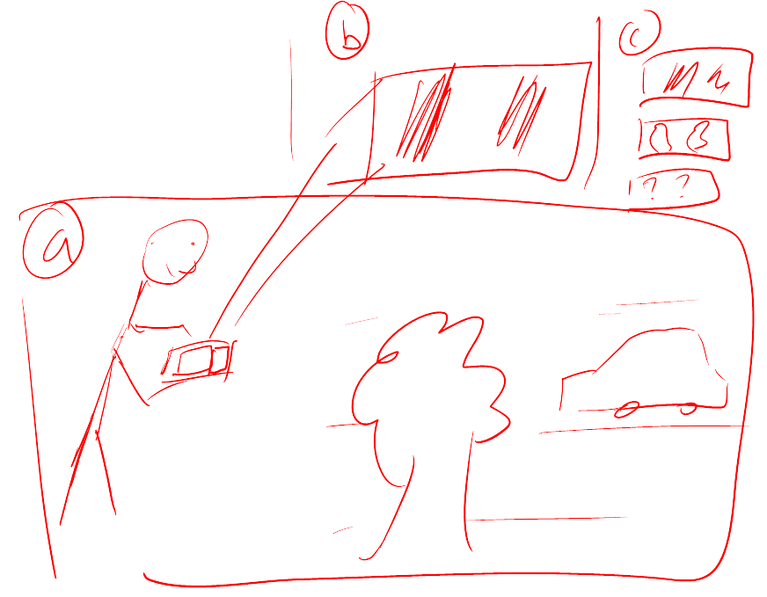
Permission to make digital or hard copies of all or part of this work for personal or classroom use is granted without fee provided that copies are not made or distributed for profit or commercial advantage and that copies bear this notice and the full citation on the first page. To copy otherwise, to republish, to post on servers or to redistribute to lists, requires prior specific permission and/or a fee.
UIST’12, October 7-10, 2012, Cambridge, MA, USA.
Copyright © 2012 ACM 978-1-xxxx-xxxx-x/xx/xx... $10.00.
Figure 1 – CrashAlert senses environmental obstacles, including static and moving objects and informs users of the positions of these objects in a minimalistic and configurable manner on the user’s display. Alerts are triggered when the user is quickly approaching an object.
We evaluated CrashAlert in an obstacle avoidance task outside a lab environment. Eight participants walked through a cafeteria during busy hours. We also provoked potential collisions unknown to the participants, such as having an ‘actor’ moving head-on or cutting off the user. Results suggest that participants were able to understand our visual alerts, felt safer using CrashAlert even after a short period of use, and their performance was not affected by the visual augmentations. We also found that with CrashAlert users were proactive in avoiding collisions.
The main contribution of this paper is a demonstration that augmenting a mobile device with additional sensors, such as a depth sensing camera along with a minimal footprint visual display of the sensor’s data can assist users in eyes-busy interaction- while walking. This contribution comes in three parts: (1) a mobile system, CrashAlert, augmented with a depth sensing camera, (2) a set of visual transformations aimed at minimizing screen space and optimizing relevant environment information, and (3) an evaluation of CrashAlert showing improved multi-tasking performance while walking.

Related work
We first report on the dangers of multi-tasking in motion due to limited peripheral alertness and then briefly describe systems aimed at improving eyes-busy interaction while walking (such as walking and texting). CrashAlert’s primary objective is in assisting users with avoiding collisions while in motion and we therefore briefly report on assistive technologies for visually-impaired users or for visually-impoverished conditions.

Dangers of multi-tasking and walking
Field studies examining the effect of cell phone use on street crossing behavior have observed that pedestrians cross more slowly when conversing on a cell phone, are less likely to look at traffic before entering the roadway, and make more unsafe crossings compared to non-distracted pedestrians [refs.]. More recently, studies have shown that users can deviate significantly from their walking path when texting and walking [ref.] and hospital reports confirm an increased number of emergency incidences related to mult-tasking/texting while in motion [refs.]. Researchers have also controlled environmental factors (i.e. car speed, traffic density) in virtual reality settings and results confirm the negative effects of multi-tasking while walking [ref. The effects worsen with more demanding tasks: pedestrians are less likely to successfully cross a road and take more time to initiate a crossing when conversing on a cell phone than when listening to music.
Results from these studies have mostly guided the efforts of policy makers but also motivate the need for novel technological interventions. Furthermore, while VR studies can control many environmental conditions, we purposefully evaluated CrashAlert in the field to evaluate the potential risks and benefits of providing users with peripheral alertness.

Walking user interfaces
A new line of research in walking user interfaces [ref.] has emerged with the goal of studying and exploring methods to assist users with eyes-busy tasks while walking. Such interfaces have mainly concentrated on aiding users in being more efficient and accurate (therefore indirectly safer) with cognitively demanding tasks such as text-entry when walking. Recent results suggest that audio feedback [ref.] and gestures that start from the device’s bezel [ref.] can better guide touch-screen input while walking. Furthermore, to aid users with text-entry while walking, researchers have introduced systems that automatically enlarge soft buttons when in motion [ref.], systems for two-handed chorded keyboard input with a stylus [ref.], and novel adaptive methods that leverages a mobile device’s tri-axis accelerometer to compensate for extraneous movement [ref.].
Relatively fewer technological interventions have been proposed to enhance peripheral alertness while multi-tasking and walking. These are limited to directly displaying on the screen the video feed from the mobile’s camera (WalkNGo) or with some limited processing to show on-coming vehicles (X). To the best of our knowledge CrashAlert is the first system to exploit transforming images from a depth camera to provide visually salient information onto a minimal footprint display.

Guidance systems for visually-impaired users and visually-impoverished environments
Haptic/audio
Navigation systems with haptic/tactile feedback
Sonar sensors
Feeback through audio or haptic, which are generally considered to be mostly processed serially or to some extent spatially [ref.].
Firefighters, pilots, rescue

Research Approach
The goal of our research is twofold. First, based on observations of actual behaviors of users interacting with mobile devices while on the go, we propose a technical solution to the problems derived from the users’ limited attention. Second, we explore the design implications for technologies aimed at alleviating the same problem. The first phase started with fieldwork observations in public places of people walking while interacting with their cellphones. From these observations we derived a set of considerations for designing a technical solution. Based on these considerations we built CrashAlert, a system prototype for helping users avoid crashes. Finally, we carried out a preliminary evaluation collecting feedback on the usefulness of the system and the different features we implemented. The second phase generalizes from our initial experience with CrashAlert and presents a design space for similar kind of systems.

Field observations
In order to better understand how users of mobile devices engage with them while on-the-go we carried out an observational study in public places. We observed over forty users in a university cafeteria and at a shopping center perform activities on their mobile devices while walking. We recorded the holding angle of the device, the number of hands used, the number of steps taken before lifting their heads [to detect on-comers and obstacles], walking patterns in slowing or speeding up, whether they had company, whether they typed, and whether the interaction ended in a phone call. Our data collection was limited to an indoor setting and it is probable that different outcomes would have been obtained by collecting data from outdoor settings as well. However it constitutes a good basis for understanding some of the behavioral phenomenon taking placed while working and walking.
Our results helped identify … [average tilt angles], [average number of steps], [avoidance strategies: dodging, heads-up, stopping], […].
These observations led to the following considerations relevant for the design of a technical system aimed at helping users avoid crashing:
[C1] – User Crashing: People seemed to slow down their pace when arriving to a crowded area or around known obstacles on their route, and in most cases it’s the multitasking subject the one crashing into an unexpected something or someone, and not the other way around [being crashed]. Therefore, the system should help the user avoid obstacles located in their direction, highlighting the unexpected like people stopping or crossing in front of the user.
[C2] – Fallback to Vision: Our observations showed that navigating and dodging obstacles and other people without lifting the head is a common practice. However, people fallback to vision when things seem complicated. Therefore, the system should identify such situations in advance and notify the users so they lift their heads and sort out the situation.
[C3] – Tilt: Mobile device users hold their device at different angles of tilt, which is important when considering the capture mechanism to use for determining what lies in front of the user. Therefore, the system should support a configurable or dynamic mechanism in order to meet different users’ preferences.

CrashAlert
Figure 2 presents CrashAlert, a system designed to provide users with ambient visualizations and visual alerts to help them avoid obstacles while multitasking on their mobile devices. CrashAlert uses both a depth and a normal camera attached to the device to capture a region of space that lies outside the user’s field-of-view; this slice of the image is processed and presented to the user on his mobile device.
CrashAlert has three main components: an ambient visualization, visual alerts for approaching objects, and a sliding window. The ambient visualization seeks to convey a glance-able representation of the elements in front of the user (C1), so that they gain an awareness of elements outside of their field-of-view as they get closer.
CrashAlert allows the user to configure the size of the visualization so that they consume minimum screen space providing maximum alertness to users.
The visual alerts are generated from the depth image and map objects that are closest to the user within a 2-meter distance. Their appearance (a red square) aims at being easily noticeable by the user and at causing their raising their head and thus to better cope with the obstacles (C2).
Finally, CrashAlert allows the user to define the region of the source images that better aligns with the front of the walking path according to the user’s particular tilt when holding the mobile device (C3). In our implementation this sliding window is manually configured by the user through a settings screen.
Figure 3 presents four different ambient visualizations provided in our initial CrashAlert implementation: (a) depth, (b) depth average columns, (c) depth mask, and (d) columns mask. The depth image is a histogram-based depth image that reduces the depth information (each pixel is a value between 0 and 10000) to a single byte (a value between 0 and 255), and paints then in a gradient from black to green (see figure 3a). The average depth columns image thresholds a grayscale version of the depth image so to filter out the remote objects, and calculates the average value for each column of pixels; this average is them assigned to all the pixels in the column (see figure 3b). The depth mask image uses the same thresholded version of the grayscale depth image and uses it as a mask on the image captured by the normal camera; this way it shows the full color version of the closest objects on a black background (see figure 3c). Finally, the columns mask image takes the 3b image and increases the value of each non-zero column to 1, this new image is used as a mask on the color image; this way it shows the closest objects plus their surroundings in the vertical dimension (see figure 3d).

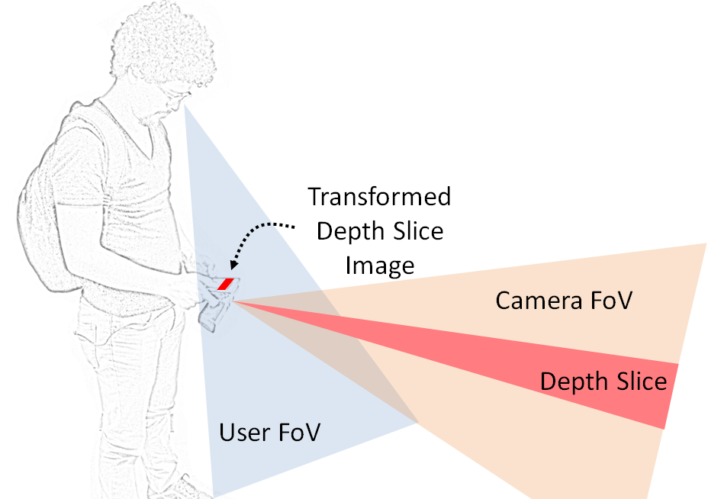
Figure 2 –A depth sensing camera can assist in extending the user’s limited peripheral view. Minimal processing on the a slice of the depth image, or depth slice, can reveal salient information about the environment. Our implementation allows for an adjustable height and position for the Depth Slice.

Implementation Details
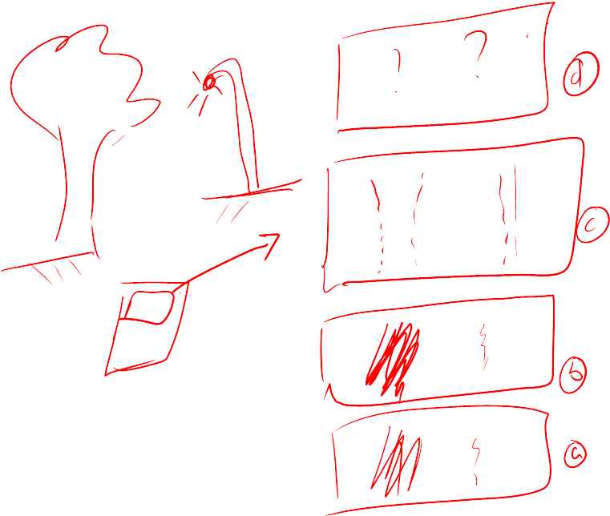
Figure 3 – Visualization types based on given scene. [Random ones, update with actual mappings] (a) Raw color image from the camera; (b) ClosestOnly shows the location of the closest object captured from the scene; (c) DepthRange displays the contents within a given range away from the user; (d) DepthMask applies the ClosestOnly or DepthRange as a mask on top of the raw color image to provide context of the object being seen.
CrashAlert is a prototype built with an Acer A100 6’’ tablet computer, a Microsfot Kinect attached to it, and a laptop computer which is carried in a backpack together with a 12 volt battery that power up the Kinect. The laptop computer receives images from the Kinect via USB, processes and transforms them, and sends them over to the tablet via Bluetooth. In normal conditions the tablet receives image frames at a rate of approximately XX frames per second.
At the software level the laptop computer runs a .NET C# application which interfaces with the Kinect through the OpenNI.net stack, processes the images with OpenCV through the Emgu.CV wrapper, and communicates them over Bluetooth through the InTheHand.Net network library. The tablet application is an Android 2.3.3 application with normal Bluetooth permissions.

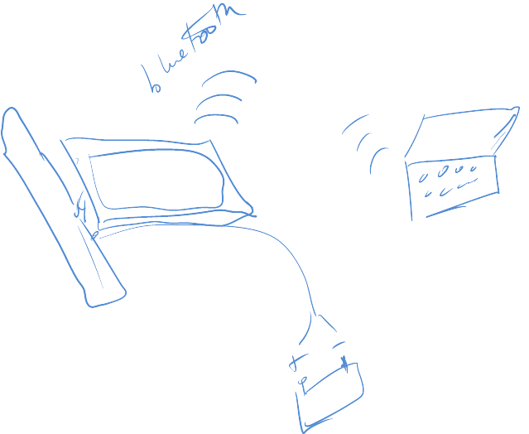
Figure 4 – Mobile tablet augmented with a Kinect depth sensing camera and, both communicating via Bluetooth to a laptop. The Kinect is powered using a 12 V battery and inverter.

EVALUATION
Our experiment was designed to determine if users could avoid obstacles while multi-tasking in a naturalistic environment. We recruited university students who habitually text and walk. Eight volunteers (6 male, 2 female, mean age of 25.5 years) from various disciplines, including computer science participated. We collected generic data about their own experiences walking and texting. X% said they do this often, another Y% indicated that a tool for texting and walking would encourage them to feel safer while texting and walking, and finally W% indicated that technological interventions should not replace users’ own peripheral senses.
We designed a within-subjects experiment in which participants were exposed to four conditions: (1) no feedback (NF), (2) camera alone (CA), (3) Depth Image (DI) and (4) Depth Mask (DM). Depth Image consisted of using the depth image or the depth columns as from Fig X. The Depth Mask was one of Fig Y or Fig Z. Have the participants did either type of depth image and depth mask conditionsThe camera was also fixed to the same angle (about 15 degs.) but participants had flexibility in determining the device’s tilt angle. The depth slice was set at a height of X cms and aimed at picking up the lower 2/3 of the depth image from the camera.

Task
We asked participants to focus on the goals of a whack-the-mole game, while walking through the university cafeteria. Each trip consisted of starting the walk at the near-by bookstore and looping around the entire easting space. Participants were asked to walk ask normally as possible while playing the game. Their objective was to tap on as many moles as possible during their trajectory. Each trial consisted of one loop around this path. Participants were asked to avoid collisions as naturally as possible. We also assured that participants would face at least four collisions during each trial. This was achieved by asking an ‘actor’, unknown to the participant to behave in certain ways that would lead to potential collisions. The ‘actor’ would cut the participants’ path orthogonally, would stop right in front of them, would come toward them at a fast pace, or would walk with them but then immediately swerve in their lane. We recorded how the participant behaved during each of these potential collisions.
We captured the user’s total walking time, the number of moles they ‘hit’ as well as the number of times they performed a ‘heads-up’, a ‘dodge’, a ‘full stop’, and a ‘slow down’. Each experiment lasted roughly half an hour. Each condition was done twice, resulting in 8 participants x 4 conditions x 2 trials = 64 trials in total.

Procedure
Participants wore the backpack containing the battery pack to which the kinect was connected to. They were first explained the task and were presented with the different visualizations. We did not inform them of the planned collisions and asked them to behave naturally while trying to complete the task as efficiently as possible. Participants walked through the cafeteria as per the assigned. Their mobile phone angle and posture was not controlled, so as to ensure a naturalistic test environment and were encouraged to hold the device in their preferred method.
They completed 2 different paths or trials per condition.
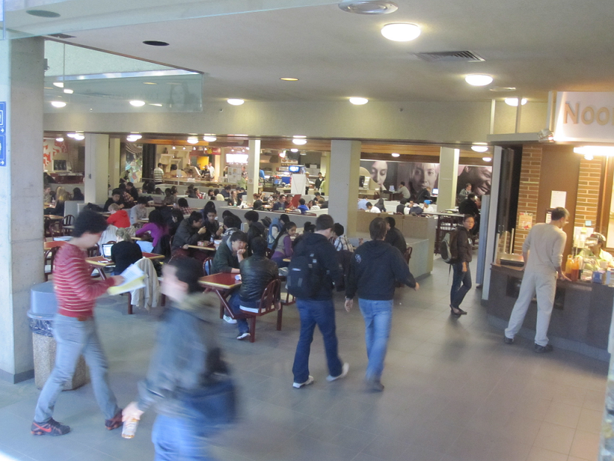 | 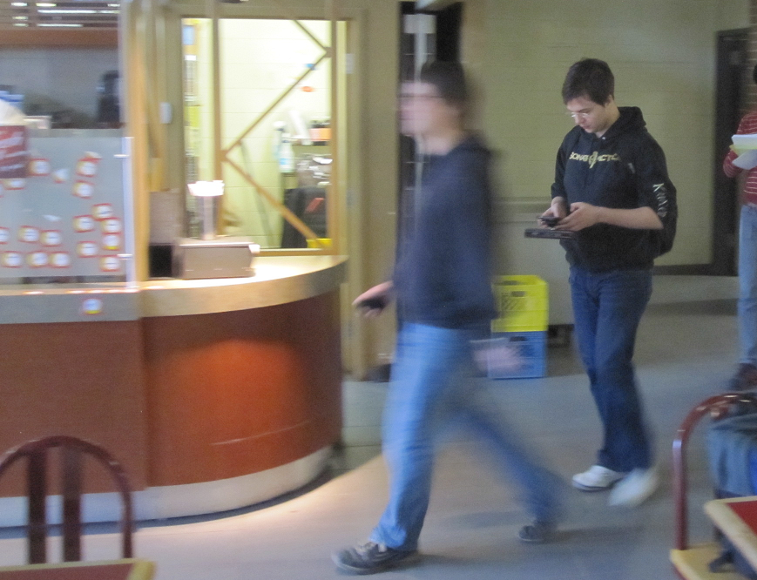
Figure 5 – (left) Experiment setting in university cafeteria. The participant is marked with circle and the ‘actor’ marked with a cross is about to provoke a collision. (right) ‘Actor’ quickly swerves into the participant’s path, the latter is still engaged in the task with the aid of CrashAlert.

Results

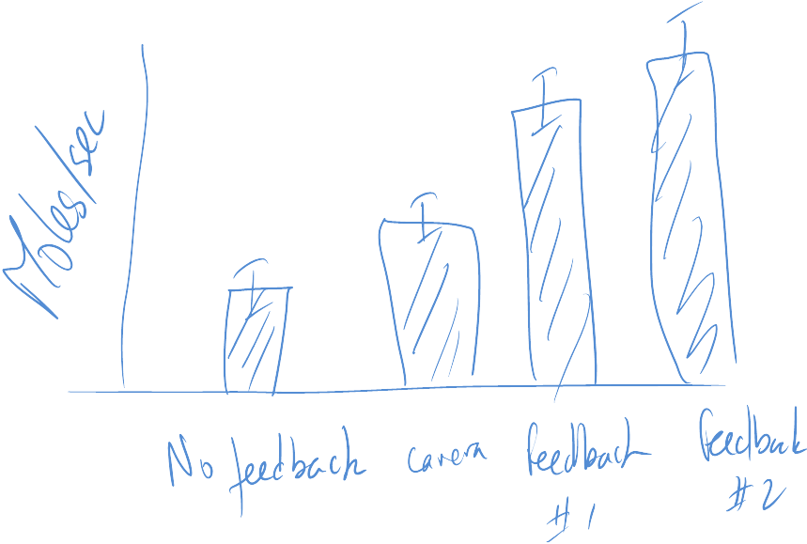

Discussion
Our informal observations and user feedback support the use of CrashAlert in avoiding daily encountered obstacles while multi-tasking on the mobile phone. Users were able to dodge passer-bys or ensure reliable avoidance while multi-tasking. We discuss our overall observations, the limitations of our current system, and provide some recommendations to designers.

Design Space
The design of CrashAlert is influenced by these four dimensions: peripheral window selection, choice of visual feedback, capture of moving objects, and …

Abstraction
- Sensor data
- Video
Window Selection
- Tilt
- Scanning for …
Presentation
- Continuous
- Discrete
- Literal
Information Delivery
- Always On
- Implicit Interaction [when it detects the user walking or then it senses obstacles approaching]
Notification Mechanism
- Visual Alerts
- Vibration
- Sound
The following table summarizes our design space definition, pointing out the particular configuration for our CrashAlert prototype and highlighting places for further exploration.
Dimension | Types of Values
Abstraction | Sensor |  |  | Video
Window Sel | Fixed |  | Tilt |  | Scanning
Presentation | Continuous | Discrete |  |  | Literal
Inf Delivery | Always On | Explicit |  |  | Implicit
Notific. Mech | Visual | Haptic |  |  | Sound

FOV mismatch
With these existing systems little is known about how much overlap exists between the user’s field of view and the camera’s field of view, i.e in other words the two FoVs overlap and are not complementary.

Depth Feedback Assists in Obstacle Avoidance

Effect of Visual Feedback on Obstacle Avoidance

Object Overlays Show Improved Performance

Policies
Talk about government policies. Perhaps policies can enforce that texting and walking be done only if users use systems such as BumpAlert to help avoid obstacles. Much testing is however necessary before such policies can be instilled.

Limitations

Recommendations to Designers

Soft

Conclusion

REFERENCES

- http://money.msn.com/auto-insurance/article.aspx?post=a8b7daf9-5e31-4cd1-a9c7-ca3979b7abc2

- How to Classify Works Using ACM’s Computing Classification System.
http://www.acm.org/class/how_to_use.html.
- hello
- Cole, William G.Understanding Bayesian Reasoning Via Graphical Displays. In Proceedings of CHI'89 Human Factors in Computing Systems (April 30–May 4, Austin, TX), ACM/SIGCHI, NY, 1989, pp. 381–386.
- Gary, M.R. Optimal binary identification procedures. SIAM J. Appl. Math. 23, 2 (Feb. 1972), 173–186.
- Garey, M.R. and Johnson, D.S. Computers and Intractability: A Guide to the Theory of NP- Completeness. Freeman, San Francisco, CA, 1979.
- Schwartz, M. Guidelines for Bias-Free Writing. Indiana University Press, Bloomington, IN, USA, 1995.

The columns on the last page should be of approximately equal length.

